Northwind Traders – Executive Dashboard (2021-2023)

1. Project Overview and Objective
Overview
This project involves cleaning, transforming, and analysing raw data using Power BI (Power Query) and creating an interactive Power BI dashboard to derive meaningful business insights.
Objective
The main objective is to demonstrate data pre-processing Power BI focuses on interactive data visualization, advanced analytics, and real time reporting from multiple data sources.

2. Data Sources
- Source Description and Timeline: Maven Analytics and 2021-2023.
- Domain: Retail

3. Problem Statement
- Difficulty in tracking overall sales performance across regions and categories.
- Lack of visibility into top performing in products and country.
- Need to interactive dashboard to support data-driven business decisions.
- To understand customer purchasing behavior to enhance marketing and retention strategies.

4. Attribute (Column )Details:
Category
Field Name | Description
Category ID | Unique category identifier
Category Name | Category name
Description | Description of category

Employee
Field Name | Description
Employee ID | Unique employee identifier
Employee Name | Last name
Title | Job Title
City | City
Country | Country

Field Name | Description
Shipper ID | Unique shipper identifier
CompanyName | Shipper name
Field Name | Description
Order ID | Links to Orders table
Product ID | Links to Products table
Unit Price | Price per unit
Quantity | Quantity ordered
Discount | Discount applied

Field Name | Description
Product ID | Unique product identifier
ProductName | Product name
Quantity | Quantity Order
Category ID | Category link
Discontinued | Product Availablity
Unit Price | Price per unit

Field Name | Description
Order ID | Unique order identifier
Customer ID | Links to Customers table
Employee ID | Links to Employees table
Order Date | Date order was placed
Required Date | Date order is required
Shipped Date | Date order was shipped
Shipper ID | Unique Shipper Identifier
Freight | Shipping cost

5. Tools & Technologies
- Power BI (Power query): Data cleaning, transformation,
- Power BI: Data modelling, DAX calculations, visualization, and interactive dashboard creation ,Create new columns and measures using DAX.

6. Data Pre-Processing (Power BI/ Power Query)

Tasks Performed:
- Data Cleaning & Transformation: Removed duplicates, handled missing values, standardized formats, and created calculated fields .
- Filtering & Sorting: Organized data to focus on relevant records.

7. Data Modelling and DAX (Power BI)
- Data Model: Established relationships between tables, defined cardinality, and created lookup tables where necessary.
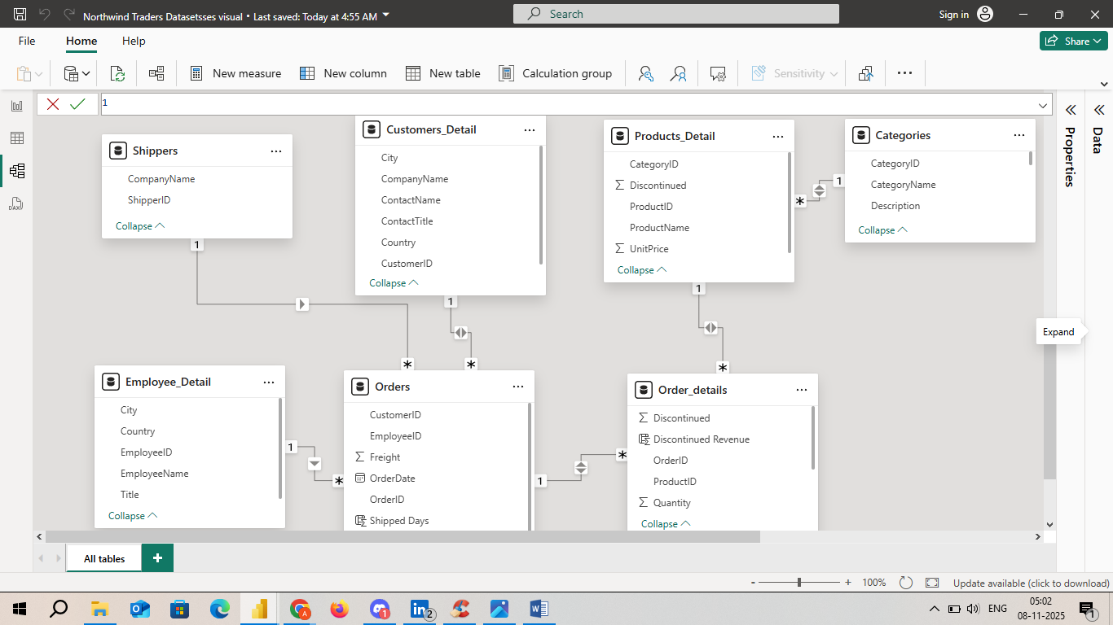
- Calculated Columns & DAX Measures: Implemented DAX formulas for key metrics, such as total sales, profit% ,total quantity, average shipped days , average freight , average discount , total costomer , total product ,total quantity , total orders, total spend .

8. Analysis and Visualizations (Power BI)

Dashboard Features:
- Multiple Visualizations based on problem statement: Bar charts, line charts, pie charts, cards, Waterfall chart , Scattered chart, Bar chart , Column chart ,Funnel chart , Speedometer .
- Make your Report interactive Layout using Drill-down, Filters and slicers ,Page Navigater .
- Clear Titles for each visuals & Labels is must.
- Create a consolidated Report /Dashboard.
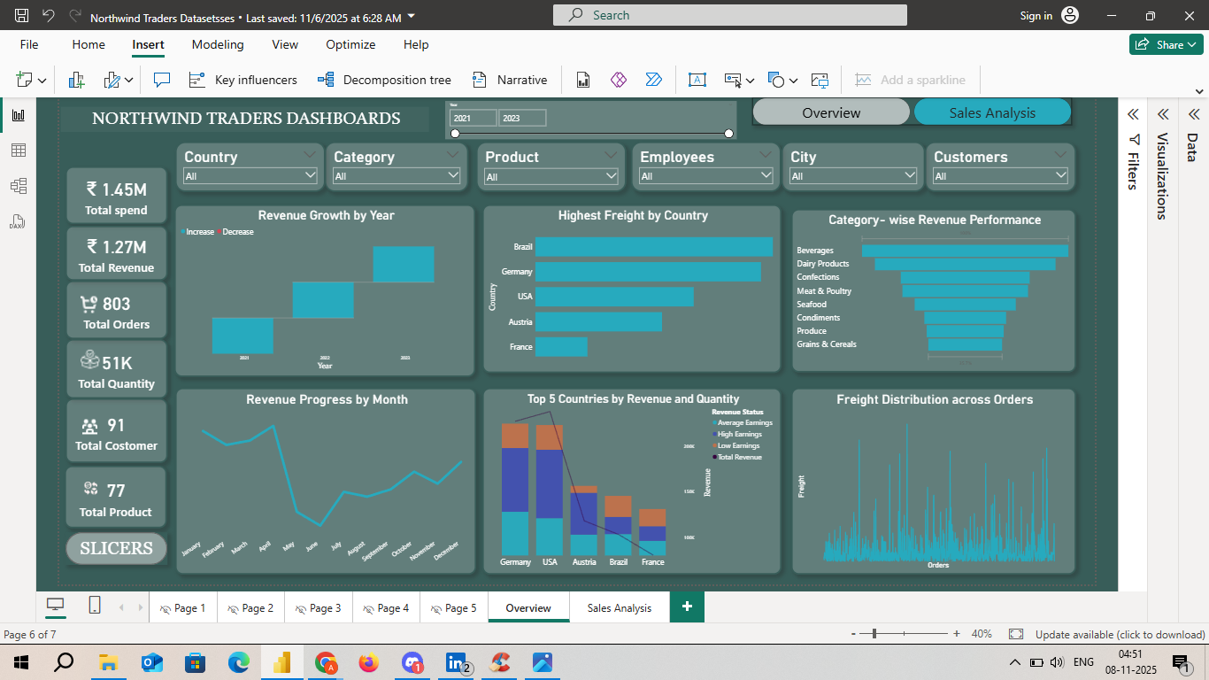
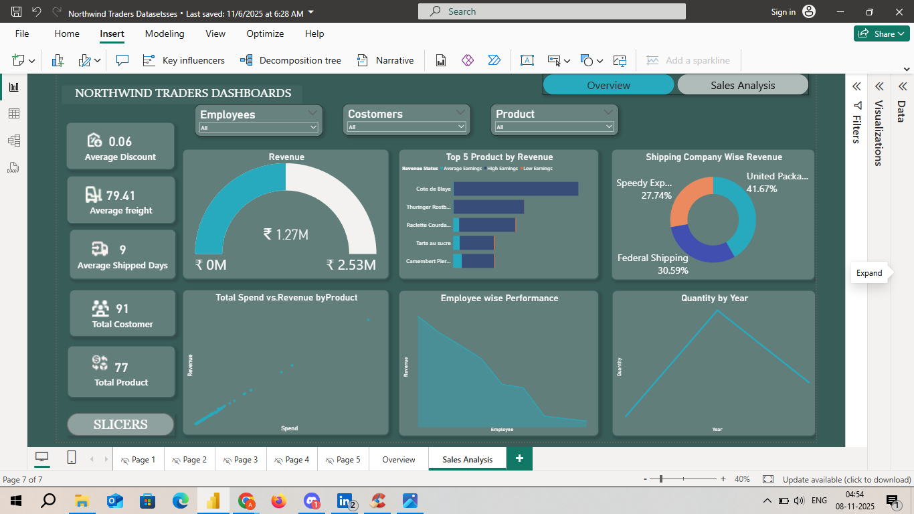

9. Insights & Conclusions
- Northwind traders demonstrate consistent sales growth with strong performance in categories and region .
- Top costomers and product drive most of the revenue .
- Shipping efficiency and discount control are areas for improvement to enhance profitability .
- Provide the analysis insights:
    - Descriptive : North wind traders shown strong and consistent sales growth in three years .
    - Diagnosis : Why Profit dipped: Discount and freight expences .
    - Predictive : If training programes are implemented , overall employee productivity could improved by 10-12% .
    - Prescriptive : By improving pricing optimizing operations , and expanding to new markets , the company can sustain growth ,improve profitability .
10. Conclusions
The integration of Excel and Power BI proved effective for end-to-end data analysis, from raw data to visual reporting.

